Gen Zs never watch TV, are stressed about Snapchat, and are concerned that technology has ruined their mental health — here's what it's REALLY like to be a teen in 2018

Rachel Premack June 29, 2018 Business Insider
Rachel Premack
- Generation Z is the most ethnically-diverse and largest generation in American history.
- They're often cast as anti-social, technology-addicted, or "social justice warriors."
- From talking to 104 teenagers nationwide, Business Insider discovered what makes today's teens stressed out, happy, curious, and connected.
Generation Z is the most ethnically-diverse and largest generation in American history.
And they're the youngest — Pew Research Center defined them recently as everyone born after 1997.
We usually view teens and the younger generations with a tinge of derision. And Gen Zs, with their obsession over Instagram and rejection of hourly work, are primed for the utmost scorn by their elders.
But we're more likely to understand what Generation Z is all about by talking to them.
Business Insider surveyed 104 Generation Zers nationwide to find out what it's like to be a teenager in 2018. Learn below about their opinions, fears, dreams, and complexities.

Business Insider surveyed 104 teens aged 13 to 19. They came from all over the US, including North Carolina, New York, and Michigan.
Many survey respondents came from WeAreGenZ, a consultancy and think tank powered by Gen Zs nationwide.
Nearly 80% of teens got their first smartphone between the ages of 11 and 13.
Almost 3% of teens got their first smartphone at age 8, and 6% at 15 or older.
- "We are the first generation to have had access to smartphones our whole lives. We communicate through social media and texts, which changes the dynamic of communication." — 19-year-old
- "Everything in our generation is immediate. Since we have been raised in an age where texts and messages can be sent in the blink of an eye, we are less patient than other generations because we are used to having instant gratification. But our generation is also very determined to show that we are capable of real thoughts and using the technology and communication methods we have been given for making change, despite what older generations expect from us." — 15-year-old
Among survey respondents, 94% had an Apple phone. That's higher than what other surveys have shown, but not shockingly so. Investment bank and asset management firm Piper Jaffray found that, in their semi-annual survey of around 6,000 American teens, 84% of teens plan that their next phone will be Apple.
Teens spend a median of five hours a day on their phone, according to the survey. But the time spent ranges considerably.
The top 25% said they spend seven hours a day on their phone — practically every moment they're not sleeping or in school. And the bottom 25% uses it for three hours.
Teens told Business Insider about their phone use: "Teenagers today are completely different because of social media. Now, we have access to this world-wide platform where we can insult or make someone look like a massive fool to millions while spreading that shame anonymously, and many parents these days don't know how to help their teenagers with that, especially when it comes to depression, anxiety, etc. — 15-year-old
- "We are all connected and grow up quicker, so we had less of a traditional childhood." — 18-year-old
- "I believe that teenagers today are fundamentally the same as in the past, but we obviously are able to gather information from a wider variety of sources and express o through different means than before – 17-year-old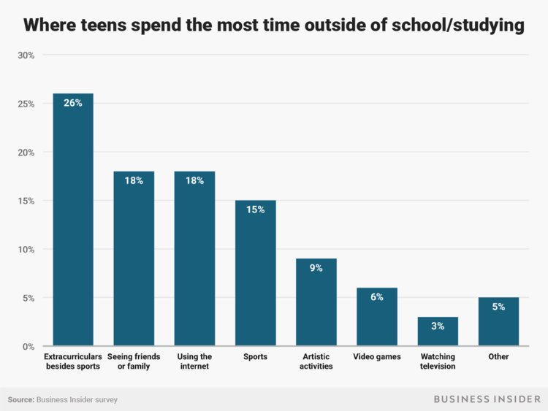
Andy Kiersz/Business Insider
When asked where they spend the majority of their time outside of school and studying, 26% of teens pointed to extracurriculars that aren't sports.
Some studies have indicated that Gen Zs are antisocial and don't spend time with their friends in real life.
But Business Insider found that just as many teens say they spend the majority of their time with friends or family (18%) as those who say using the internet (18%) accounts for the majority of their day. Artistic activities, sports, and video games accounted for the rest of the responses.
A 2016 study by Nielsen revealed that American adults spend an average of five hours and four minutes a day watching television.
Business Insider found that Gen Zs watch a lot less television than their predecessors. Only a quarter of teens say they watch four or greater hours of television per day.
A third of teens watch an hour or less of television every day. According to AwesomenessTV, Gen Zs said cable television is best for watching TV with family (43%) or falling asleep (33%).
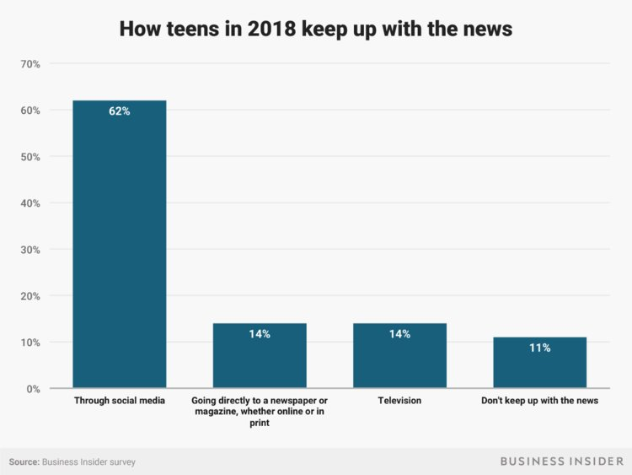Andy Kiersz/Business Insider
In 2017, 37% of Americans got their news from local TV. That number shot up to 57% among those aged 65 or older.
Gen Zs aren't so fond of television news, Business Insider found. Just 14% said it's their main news source.
Six out of 10 said they prefer social media platforms to get the news — and 10% said they don't keep up with the news at all.
Only 5% of those aged 65 and up watch television through a streaming service, according to Pew Research.
"There are more options than on cable, since you can rewind or fast forward and watch older shows like Friends easier," a 15-year-old told Business Insider.
Streaming wins for the lack of commercials and variety of options. Teens told Business Insider:
- "It's lot easier to find something you like and watch it that second! Netflix especially has a lot of great original movies/shows." — 15-year-old
- "You can choose what you want to watch when you want to." — 14-year-old
They said it's free, caters to their hobbies, and, because many YouTubers are teenagers, the content is more relatable. Teens told Business Insider:
- "The content on YouTube is so much more diverse and funny and relatable. The stuff on TV is so outdated. I would watch Netflix, but I don't have the money to sign up." — 16-year-old
- "YouTube is full of content that people create to keep their fans entertained with gameplay and animation about their lives, which is something that real TV doesn't really have." — 14-year-old
- "People upload videos from anywhere and they're entertaining." — 15-year-old
Teens told Business Insider that these are their most-used slang words.
Here's what they mean.
Lit: When something is very exciting or energetic — like a "lit" party.
Bet: "Bet" is usually a one-word agreement — sort of like "I bet you do." You can replace "Ok" with "bet."
Shook: Shocked or surprised. Can't believe what you're seeing.
Yeet: Yeet was a dance that went viral on Vine in 2014. Now it can be used as an expression of excitement or a verb to describe someone throwing something over a long distance.
Key: The more succinct sibling of "major key," key indicates something important or vital to one's success.
Slay: Succeeded in something amazing.
Three-quarters of respondents picked Snapchat, Instagram, and YouTube as their most-used. "You get to see what everyone is up to," a 19-year-old told Business Insider.
More than half of teenagers told AwesomenessTV that it's easier to be themselves onlinethan it is in the real world. Teens told Business Insider:
- "I like Instagram the most because I think pictures tell more than just words." — 17-year-old
- "Snapchat is just one of the most common social media for me and my friends." — 17-year-old
Teens told Business Insider:
- "I can scroll through them and not get bored." — 18-year-old
- "They are entertaining and I can always find things when I'm bored." — 16-year-old
In 2016, Business Insider found that today's teens actually like Twitter more than their millennial or Gen X cohorts.
Teens told Business Insider:
- "I get to talk to my friends and see interesting things about shows or bands I like, or see funny memes." — 14-year-old
- "I like Twitter because it is how I keep up to date with things going on in the world." — 17-year-old
- "It's easy to see content from other people who aren't your friends in real life" — 15-year-old
The same message came up again and again: Facebook is filled with their parents, not their peers. Teens told Business Insider:
- "Facebook is outdated and filled with old people." — 18-year-old
- "My friends aren't on Facebook." — 15-year-old
- "Facebook transitioned to being social media that's mostly used by parents, so it's lost most of its appeal." — 17-year-old
- "Not many people our age use Facebook." — 14-year-old
Nearly 57% of teens said they use iMessage or SMS the most to talk with friends.
More than a third named Snapchat text as their No. 1 communication method, which disappears once opened, and almost 8% picked Instagram direct message.
Just 1% said Facebook Messenger was their most-used communication method.
Lots of teens said they were addicted to keeping up Snapchat streaks, which are consecutive days of exchanging Snaps with another person. Some said they would accrue hundreds of days of consecutive Snapchats, which is signified by a flame emoji next to the contact's name and the number of days where a streak was maintained.
One 15-year-old said she had friends who kept streaks of hundreds of days with 20 or more people.
But now some told Business Insider that the consuming social media has become too much energy:
- "Snapchat is draining to keep up streaks. Even though people still do, lots of people say they hate it." — 16-year-old
- "Everyone on Snapchat was annoying about streaks." — 15-year-old
- "Snapchat is too much work." — 15-year-old
In our survey, 26% of teens said Apple Music is their top music app, while 60% chose Spotify.
Despite its popularity for video content, just 4% picked YouTube as their most frequently-used music service.
The remaining 10% were split among Soundcloud, Pandora, iHeartRadio, Google Play, and Trebel.
They said technology addiction is rampant among their generation. Teens told Business Insider:
- "I think the biggest hurdle my generation will have is removing themselves from their electronics. Teens are very addicted to electronics." — 15-year-old
- "We aren't personable in real life because we put too much energy in our phones and social media." — 19-year-old
- "The biggest hurdle will most likely be our soft skills, our ability to hold a conversation in person effectively." — 18-year-old
- "Teens now are too obsessed with their image on social media and what's going on with celebrities than with the real world." — 17-year-old
"This digital generation satisfies so much of their novelty-seeking impulses through their phones, they hardly have the time or interest to pursue these old vices altogether," wrote the researchers at AwesomenessTV in a recent report.
Teens are less likely to have sex, try drugs, drink, and other classic adolescent risk-taking behavior — and some say that's because they're so taken by technology.
Teen birth rates are now a third of what they were in 1990. Drug use and drinking rates are also markedly lower from previous decades.
Gen Zs' short lives have been marked by political turmoil and contentious national debates.
Older Gen Zs have early memories of September 11 and witnessed the historic presidential elections of both Barack Obama and Donald Trump. Teens have also been notably involved in gun control awareness protests. And Americans believe more than ever that climate change is happening due to human activity.
Teens told Business Insider:
- "The biggest hurdle for my generation will be the environment and the polarization of political parties currently. By environment, I mean my generation will be confronted with figuring out how to do their part to make positive changes in protecting the environment and science in general. In terms of polarized political parties, my generation will have to navigate a world that is trying to be black and white, but really has so much gray area." — 19-year-old
- There is entrenched unrest around the globe without obvious solutions, and our planet is slowly dying." — 18-year-old
Nearly 10% of teens said debt and the economy will be the biggest roadblock for Gen Zs. They're particularly worried about how they'll pay for college.
An equal amount pointed to social justice and identity issues:
- "Honestly, social injustices are going to be a really big thing throughout my lifetime. Many things are being brought to light and I don't see them going away any time soon." — 17-year-old
- "Ending police brutality towards black people." — 16-year-old
A quarter of Gen Zs summarized their generation's mood as "stressed." And 17% opted for "depressed."
Seven percent of teens told Business Insider that mental health will be a major problem for Generation Z. "Dealing with and overcoming stress and anxiety and depression issues," a 17-year-old told Business Insider.
Teens told Business Insider:
- "Our biggest hurdle will probably be learning how to function on your own." — 14-year-old
- "I believe that Generation Z will have to overcome the fact that we are not as prepared for adult life as we think. While we're politically informed, I don't think we're practically informed, if that makes sense. Most of us don't know how to do things, like, balance a checkbook and pay bills." — 15-year-old
- "Showing older generations that we are more than kids that are just attached to their phones, that we do have opinions that need to be heard, and that we have skills to offer that older generations never had. Upside to being a digital native!" — 17-year-old
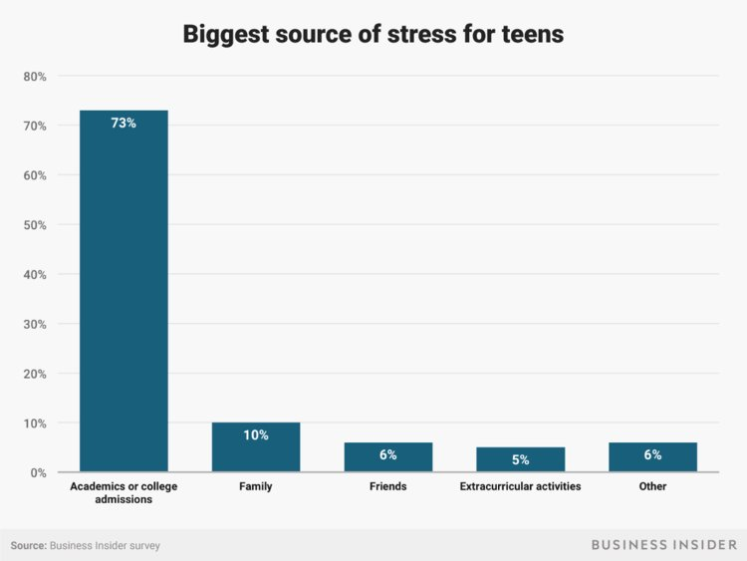Andy Kiersz/Business Insider
Nearly three-quarters of teens said their biggest source of stress was academics or college admissions.
"Most of my friends and I are almost constantly on edge. We have a lot of stress in our lives and always seem to put too much on our plates," a 17-year-old told Business Insider. "We also just have a more cynical outlook in general and are less sure about the security (financially and otherwise) of our futures."
Family was distant second at 10%, with friends and extracurricular activities following.
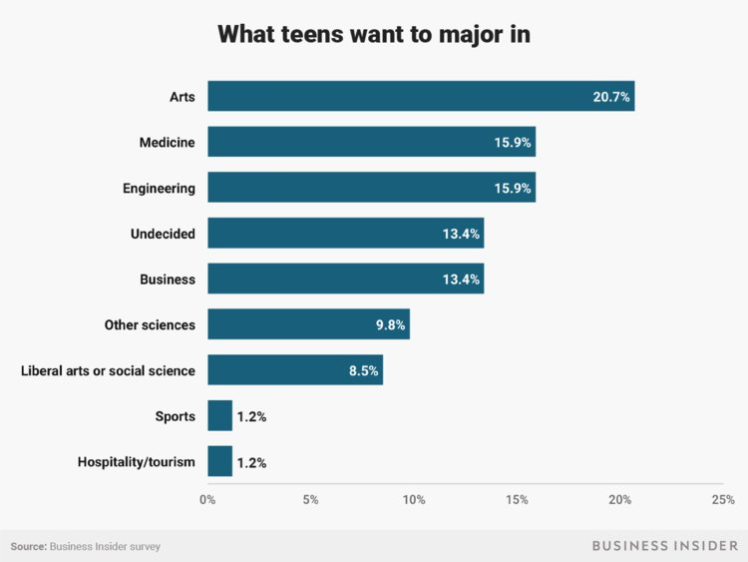Andy Kiersz/Business Insider
Business Insider categorized what respondents said they want to major in, and certain trends became clear.
A fifth want to major in creative fields, like dance or graphic design. At 16% each, health and engineering shared second-place popularity. Business, other science fields, and liberal arts majors trailed behind.
Teens told Business Insider:
- "Today, teenagers are infinitely more well-informed. We're able to form our own opinions on issues, as we're able to immediately access both sides of an argument online." — 15-year-old
- "Geographic location is not a problem and does not define who we are. Though the US is a mostly a Christian nation, atheism is increasing and Asian cultures, like anime and K-pop, are becoming more and more popular among Gen Z and even millennials." — 18-year-old
- "The availability of information allows modern teens to be more informed and causes them to be more disillusioned than those of past generations." — 18-year-old
Almost 3% of teenagers in 2018 don't identify as either male or female — a significant uptick from previous year. Almost half of Gen Zs are minorities, compared to 22% of Baby Boomers.
They're in favor of a variety of social movements, according to AwesomenessTV. Eight in 10 support Black Lives Matter, 74% are in favor of transgender rights, and 63% support feminism.
Teens told Business Insider:
- "We've broken a lot of stereotypes in our generation." — 17-year-old
- "Teens now are more motivated to be the change they really want to see in the world. This generation is more determined to actually make a difference in their lifetime and see the fruit of their labor." — 19-year-old

